Database Management System (CO-202)



-PROJECT TITLE-

Doctor-Patient Networking Platform

**SUBMITTED BY:**

**2K19/CO/130**

**Diwyanshu**

**SUBMITTED TO:**

**Professor Manoj Sethi**

**Department of CSE**

**Delhi Technological University**

**DEPARTMENT OF COMPUTER SCIENCE AND ENGINEERING**

**DELHI TECHNOLOGICAL UNIVERSITY**

**(Formerly Delhi College of Engineering)**

**Bawana Road, New Delhi-110042**

CERTIFICATE

**CERTIFICATE**

On the basis of the Project submitted by Diwyanshu (2K19/CO/130), student of B.Tech. (COE) I hereby certify that the project titled “**Doctor-Patient Networking Platform**” which has been submitted to Department of Computer Engineering, Delhi Technological University in the fulfilment of the requirement for the assessment of 4th semester in Computer Engineering, is an original contribution with existing knowledge and faithful record of work carried out by him under my guidance and supervision.

Place: -Delhi                                                                            Professor Manoj Sethi

Date: - 30th Apr 2021                                          Delhi Technological University

**DEPARTMENT OF COMPUTER SCIENCE AND ENGINEERING**

**DELHI TECHNOLOGICAL UNIVERSITY**

**(Formerly Delhi College of Engineering)**

**Bawana Road, New Delhi-110042**

CANDIDATE’S DECLARATION

I, Diwyanshu (2K19/CO/130), the student of B.Tech (COMPUTER Engineering, Class of 2023), hereby declare that the project titled “Doctor-Patient Networking Platform” is submitted by me to Professor Mr. Manoj Sethi, in fulfilment of the requirement for the Innovative Work of fourth semester for the subject *DBMS CO-202.* It is original and not copied from any source without proper citation. All the sources used have been duly notified in this project. I would like to extend sincere thanks to all of them. This work has not previously formed the basis for the award of any Degree, Diploma Associateship, Fellowship, or other similar title or recognition.

**SUBMITTED BY:**

**Diwyanshu**

**2K19/CO/130**

**SUBMITTED TO:**

**Professor Manoj Sethi**

**SUPERVISOR**

**Faculty DBMS CO-202**

**Delhi Technological University**

**DEPARTMENT OF COMPUTER SCIENCE AND ENGINEERING**

**DELHI TECHNOLOGICAL UNIVERSITY**

**(Formerly Delhi College of Engineering)**

**Bawana Road, New Delhi-110042**

ACKNOWLEDGEMENT

I have taken sincere efforts in this project. However, it would not have been possible without the kind support and help of many individuals and organizations. I would like to extend my sincere thanks to all of them. I am highly indebted to DTU and especially Mr. Manoj Sethi, my Faculty, for his guidance and constant supervision as well as for providing necessary information regarding the project and also for his support in completing the project.

Thank you

Index

**CHAPTER 1 6**

PROJECT INTRODUCTION AND BROAD OUTLINE

1.1 Introduction………………………………..........…………………………….6

1.2 Broad Outline of Project……………………………………………………7-8

**CHAPTER 2 9**

PROJECT CONTENT

2.1 REGISTRATION PAGE OF WEBSITE………………………....8-17

2.2 STYLING REGISTRATION PAGE USING CSS………………17-20

2.3 INDEX PAGE OF SITE……………………………………………….20-21

2.4 DESCRIPTION OF COMPONENTS OF INDEX PAGE……21-24

2.5 OBJECT ORIENTED APPROACH………………………………..24-27

2.6 AJAX………………………………………………………………………..27-28

**CHAPTER 3 29**

**LEARNING OUTCOMES, CONCLUSIONS, INNOVATIVE APPROACH AND ANALYSIS……..**….29

3.1 LEARNING OUTCOMES…………………………….….……………….…………….……29

3.2 CONCLUSION……………………………………………………………………………………29

3.3 INNOVATIVE APPROACHES………………………………………………………………29

3.4 ANALYSIS……..…….……………………………………………………………………………29-30

**CHAPTER 4 31-33**

**REFERENCES AND PLAGARIASIM**

4.1 REFERENCES……...........................................................................31

4.2 PLAGARIASIM REPORT……………………………………………………………..32-33

# Introduction

This project is focused on making a social networking platform for patients and doctors using HTML, CSS, JavaScript for frontend and Php and MySQL as backend. I have used XAMPP to host the project on my computer’s localhost. I have used PhpMyAdmin for making database. Project is made using an Object-Oriented Approach.

A social networking platform is a service to build social relations among people by providing means to users for interacting with other people. During this pandemic period, we observed the shift to online medium for various fields like education, shopping, entertainment etc. Although some sectors like medical sectors cannot be entirely shifted to online medium. But we can reduce some of the burden by having an online system. Online system would also help to control COVID spread by reducing physical contact among people.

This platform includes features like newsfeed, profiles, friend system etc. It provides a service to register to a networking platform where users can upload posts and other users can add them as friend/follow them, react on posts by likes and comments.

While making personal projects like these students tend to miss some programming practices that can make the project not applicable in real world. This project follows best programming practices so that it is ready to deploy for real world usage.

Broad Outline of project

# Register/Sign Up page

This is a page which asks first time users to register on the platform. It asks for first name, last name, email, password etc. It has functionality like storing password in database using md5 encryption, striping tags to prevent problems like code injection, assigning a random funny profile picture to newly registered user, generating unique username in database if some users have same name, validating if email already exists in database, inserting all values to database, displaying various error messages like email don’t match, password length insufficient, etc.

# Login Page

Login page is also integrated into register.php page. The register.php page also has a session variable functionality. Why session variable? When a user submits the form but there are things that need to be corrected e.g. the passwords do not match, at the moment, it resets the form which means the user will have to enter all of the values again. But by storing variables of the session when the user submits the form, it remembers the values and re-fills the text fields with those values to save the user having to type them out again.  For the login page, it stores the email in a session variable so that the user doesn't have to type their email again and also displays the error message.

# Index page

The basic structure of the index page is a top bar, a left column, which has a small panel displaying the user info of user who is logged in like user’s profile picture, user name, number of posts, likes and a right column, which is the newsfeed in which users can post, like/comment on posts. The newsfeed’s data is also stored in MySQL database in three tables- posts, comments, likes.

# Newsfeed

In newsfeed, users can upload posts, view posts from their friends, like and comment posts etc. It also has the functionality of timestamps for every part (posts, likes and comments). Newsfeed is optimised in various ways. There is a User’s class which performs SQL queries and fetches required data for newsfeed. The newsfeed works on an Object-Oriented approach. It creates objects of user class and then displays output on the feed. The posts fetching part is also optimal. The newsfeed works by fetching only 10 posts from the database at a time. If the user scrolls down till the end only then another 10 posts are fetched from database.

Project Content

# Registration Page

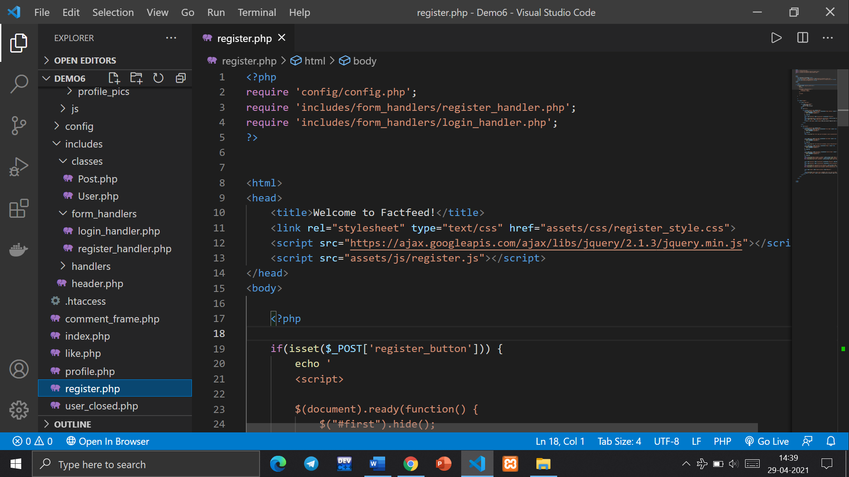

It is made using a HTML form using method POST and then styled using CSS. It gets the variables sent from the form and store them in session variables. Register and Login form handlers are included in the main register.php page

* **Register_handler.php**

This php file contains all the backend code for new user registration. It is made using a HTML form using method POST and then styled using CSS.

It gets the variables sent from the form and store them in variables.

* **Registration page**

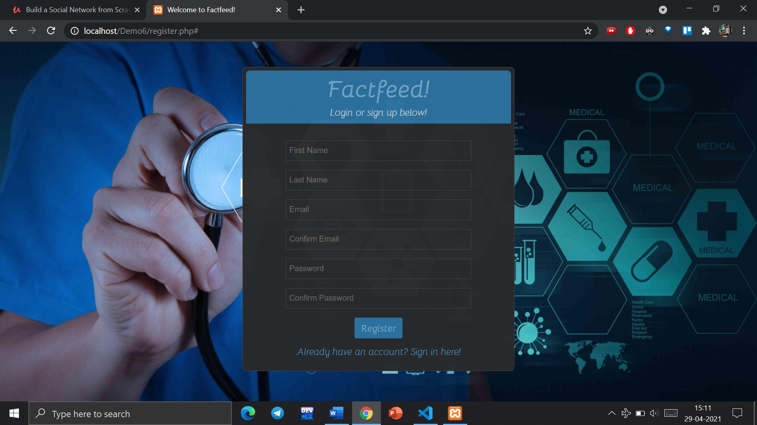

* **Storing registration form values**

This code gets the variables sent from the form and stores them in variables in following manner. Before storing the variables in dtabase we need to takes care of three main points.

* Strip HTML and Php tags using strip_tags function
* Replace double spaces if any, with single spaces
* All names must in same format eg . Abcdef Shg. First letter uppercase and only single spaces between strings.
* **Storing values in session variables**: When a user submits the form but there are things that need to be corrected e.g. the passwords do not match, at the moment, it resets the form which means the user will have to enter all of the values again. But by storing variables of the session when the user submits the form, it remembers the values and re-fills the text fields with those values to save the user having to type them out again.

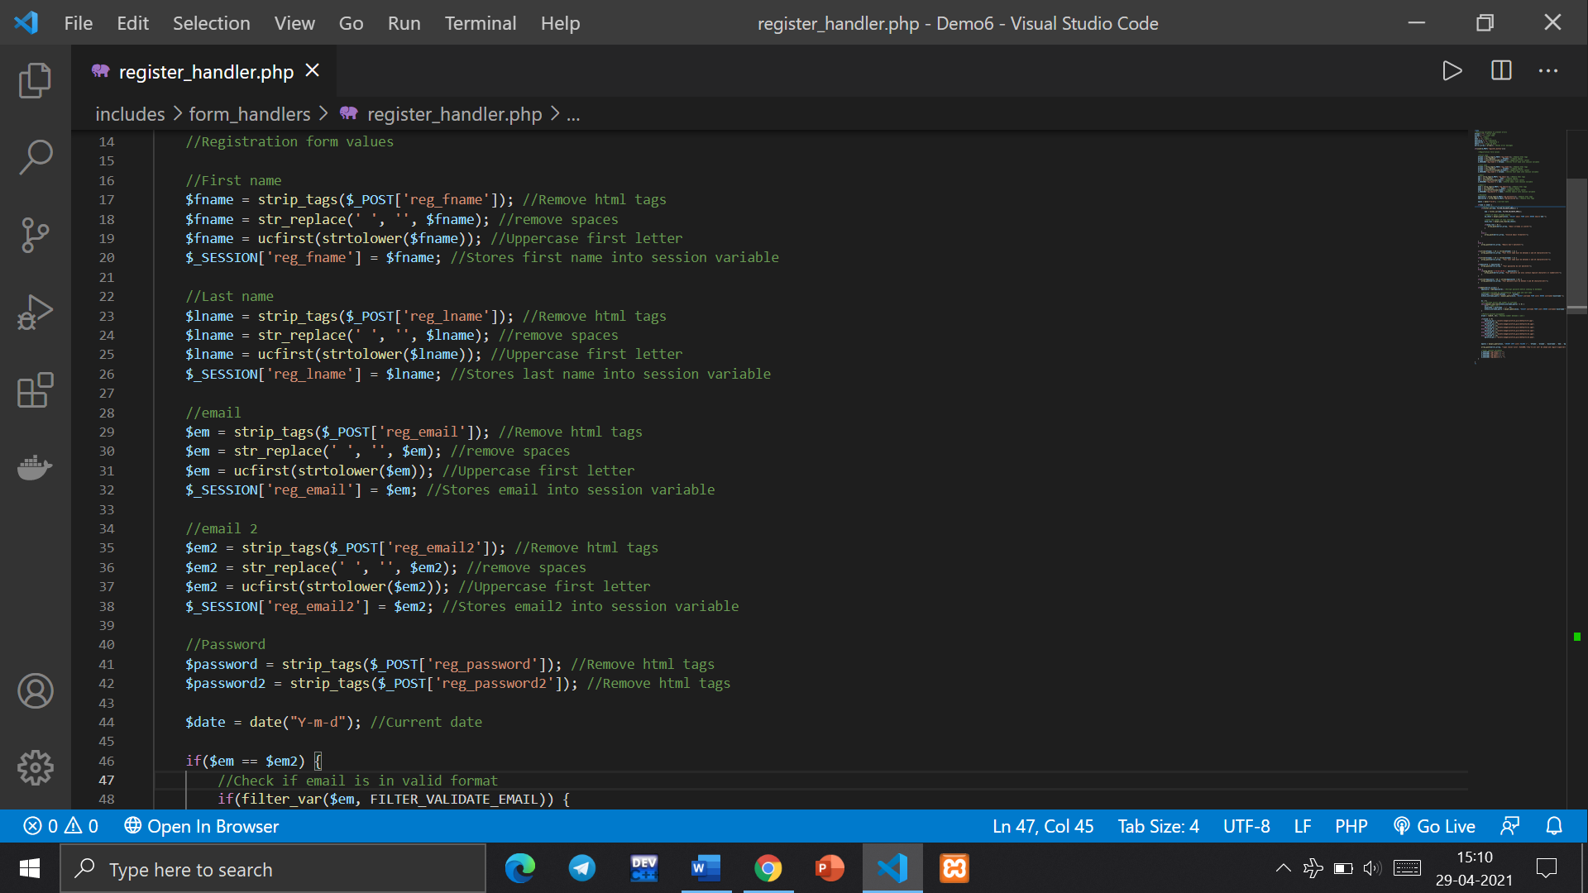

**Functions Used:**

* **PHP strip_tags function**

**Strip_tags()** is a function that allows you to strip out all HTML and PHP tags from a given string. This is to prevent any vulnerabilities related to code injection. Code injection, also called Remote Code Execution (RCE), occurs when an attacker exploits an input validation flaw in software to introduce and execute malicious code. Code is injected in the language of the targeted application and executed by the server-side interpreter. Any application that directly uses unvalidated input is vulnerable to code injection, and web applications are a prime target for attackers. By stripping HTML and PHP tags, our project becomes safe from such vulnerabilities.

* **str_replace function**: Replace all occurrences of the search string with the replacement string. The **str_replace()** is a built-in function in PHP and is used to replace all the occurrences of the search string or array of search strings by replacement string or array of replacement strings in the given string or array respectively.

**Syntax:** str_replace ( $searchVal, $replaceVal, $subjectVal, $count ) **Parameters:** This function accepts four parameters out of which 3 are mandatory and 1 is optional. All of these parameters are described below:

**$searchVal:** This parameter can be of both string and array types. This parameter specifies the string to be searched and replaced.

**$replaceVal:** This parameter can be of both string and array types. This parameter specifies the string with which we want to replace the $searchVal string.

**$subjectVal:** This parameter can be of both string and array types. This parameter specifies the string or array of strings which we want to search for $searchVal and replace with $replaceVal.

**$count:** This parameter is optional and if passed, it’s value will be set to the total number of replacement operations performed on the string $subjectVal.

* **ucfirst function:** Make a string's first character uppercase. The **ucfirst()** function is a built-in function in PHP which takes a string as an argument and returns the string with the first character in Upper Case and all other characters remain unchanged.

**Syntax:** ucfirst($string)

**Parameter:** The function accepts only one parameter $string which is mandatory. This parameter represents the string whose first character will be changed to uppercase.

Return Value: The function returns the same string only by changing the first character to upper case of the passed argument $string.

* **strtolower function:** Make a string lowercase. The strtolower() function is used to convert a string into lowercase. This function takes a string as parameter and converts all the uppercase english alphabets present in the string to lowercase. All other numeric characters or special characters in the string remains unchanged.

**Syntax:** string strtolower( $string )

**Parameter:** The only parameter to this function is a string that is to be converted to lower case.

**Return value:** This function returns a string in which all the alphabets are lower case.

* **Validating Emails**

This code validates the email by making sure that the two emails entered match and that they are in the correct format for an email. It also checks if some user already exists on the mail that is entered. It uses SQL query to fetch all emails from data base. Then using a simple counter variable, it can validate if the email is repeated. If the email is repeated then it sends the error to an array which holds all error messages.

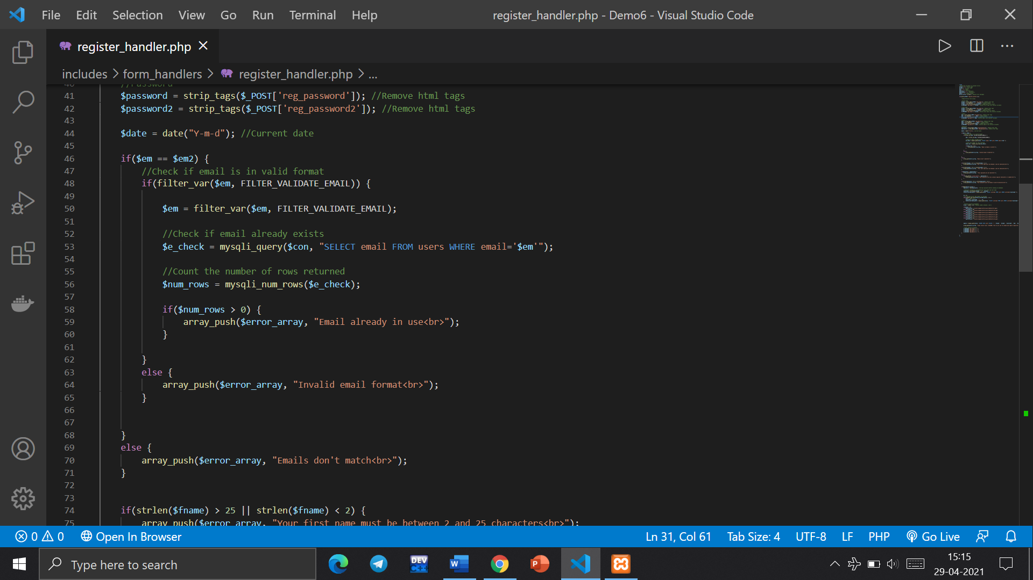

It uses 3 if statements

* One to check if the emails match.
* Second to check if the email is in valid format.
* Third to check if some user already exists on that email.

**Functions used**

* **Filter_var():** The filter_var() function filters a variable with the specified filter. This function is used to both validate and sanitize the data.

**Syntax :-** filter_var(var, filtername, options)

**Parameters:** This function accepts three parameters and are described below:

var : It is the required field. It denotes the variable to filter.

filtername : It is used to specify the ID or name of the filter to use. Default is FILTER_DEFAULT, which results in no filtering. It is optional field.

options : It is used to specify one or more flags/options to use. Check each filter for possible options and flags. It is also optional field.

**Return Value:** It returns the filtered data on success, or FALSE on failure.

* **Mysqli_query():**The mysqli_query() function accepts a string value representing a query as one of the parameters and, executes/performs the given query on the database.

**Syntax** mysqli_query($con, query)

**Parameters**

1. $con(Mandatory) This is an object representing a connection to MySQL Server.
2. 2 query(Mandatory) This is a string value representing the query to be executed.
3. 3 mode(Optional) This is a integer value representing the result mode. You can pass MYSQLI_USE_RESULT or MYSQLI_STORE_RESULT as values to this parameter.

**Return Values** For SELECT, SHOW, DESCRIBE and EXPLAIN queries this function returns a mysqli_result object holding the result of the query in case of success and, false if failed. For other queries this function returns an boolean value which is, true if the operation/query is successful and, false if not.

* **Validating first name, last name and password**

This code ensures below listed conditions. The code is written in such a way that all the errors are stored in an array. At last it is checked if the array is empty or not. Only when the array is empty (which means no errors), the values stored in session variables are inserted into database.

* First name is between 2 and 25 characters.
* Last name is between 2 and 25 characters.
* Both Passwords entered must match.
* Password can only contain English characters or numbers
* Password must be between 5 and 30 characters

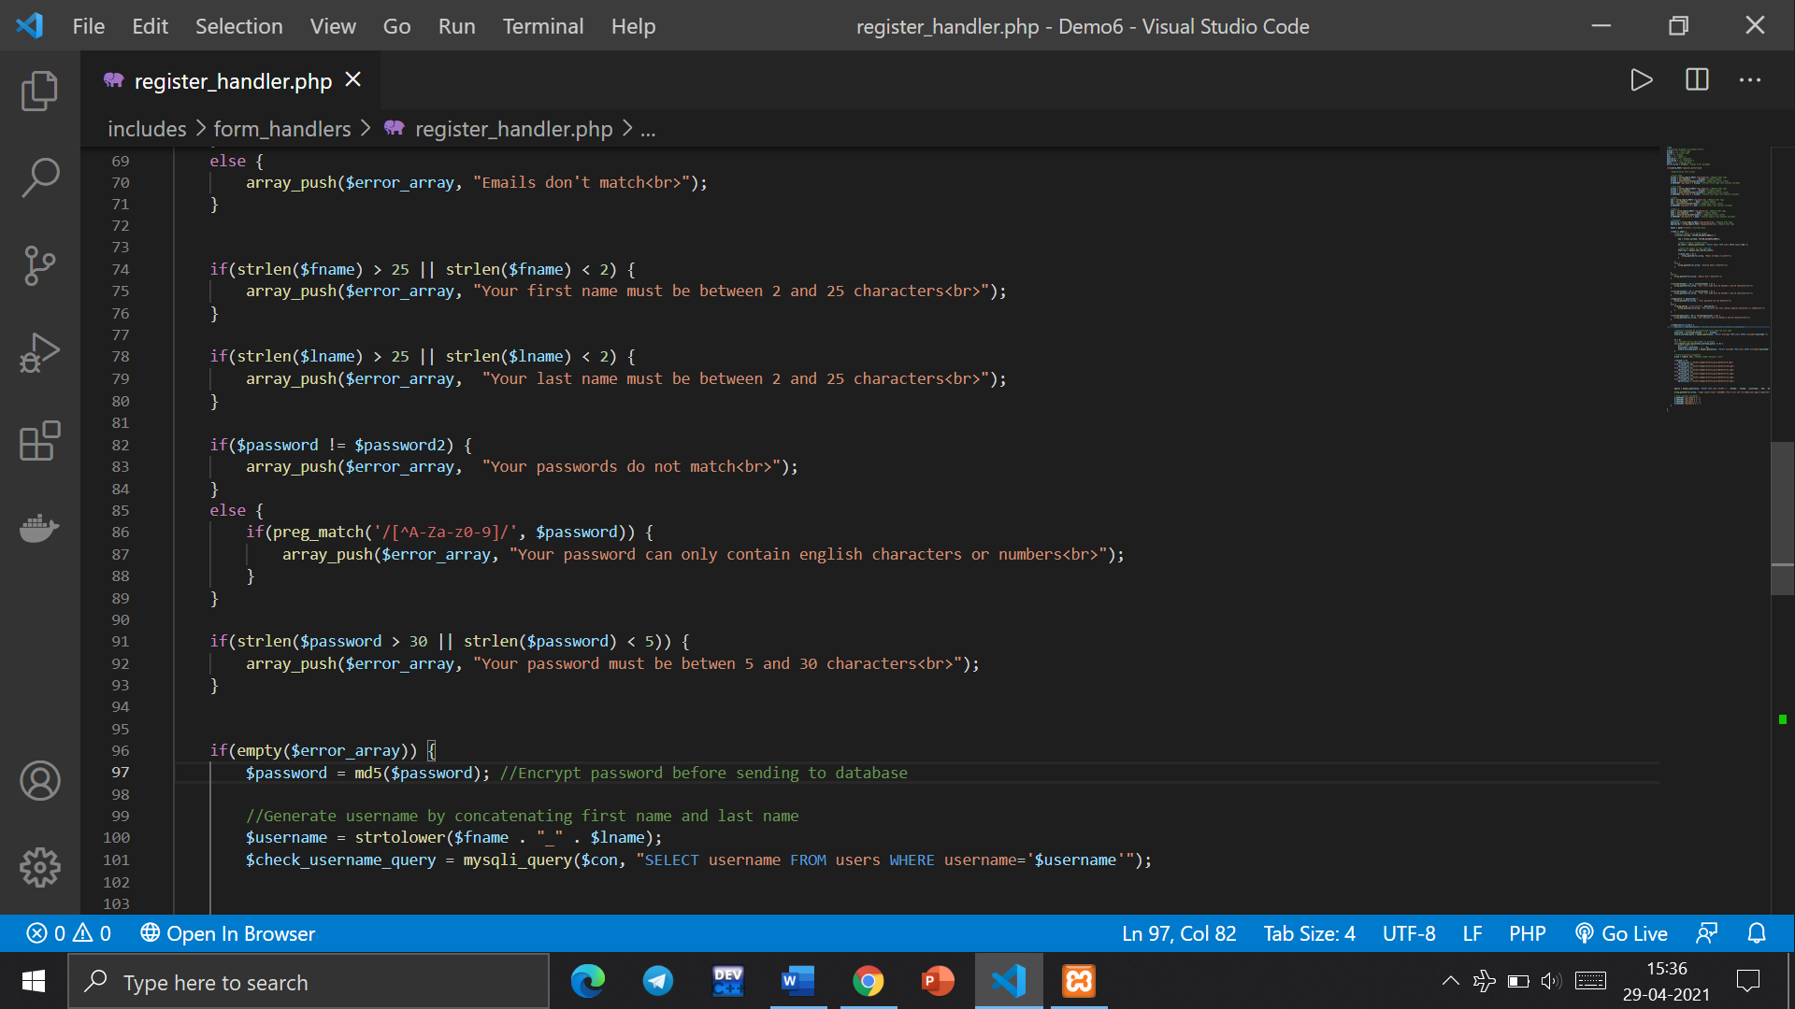

* Once error array is empty following functions are performed

1. Md5 encryption of password before sending it to database.
2. Generate username by concatenating first name and last name.
3. Generating a unique username: If username exists add number to username

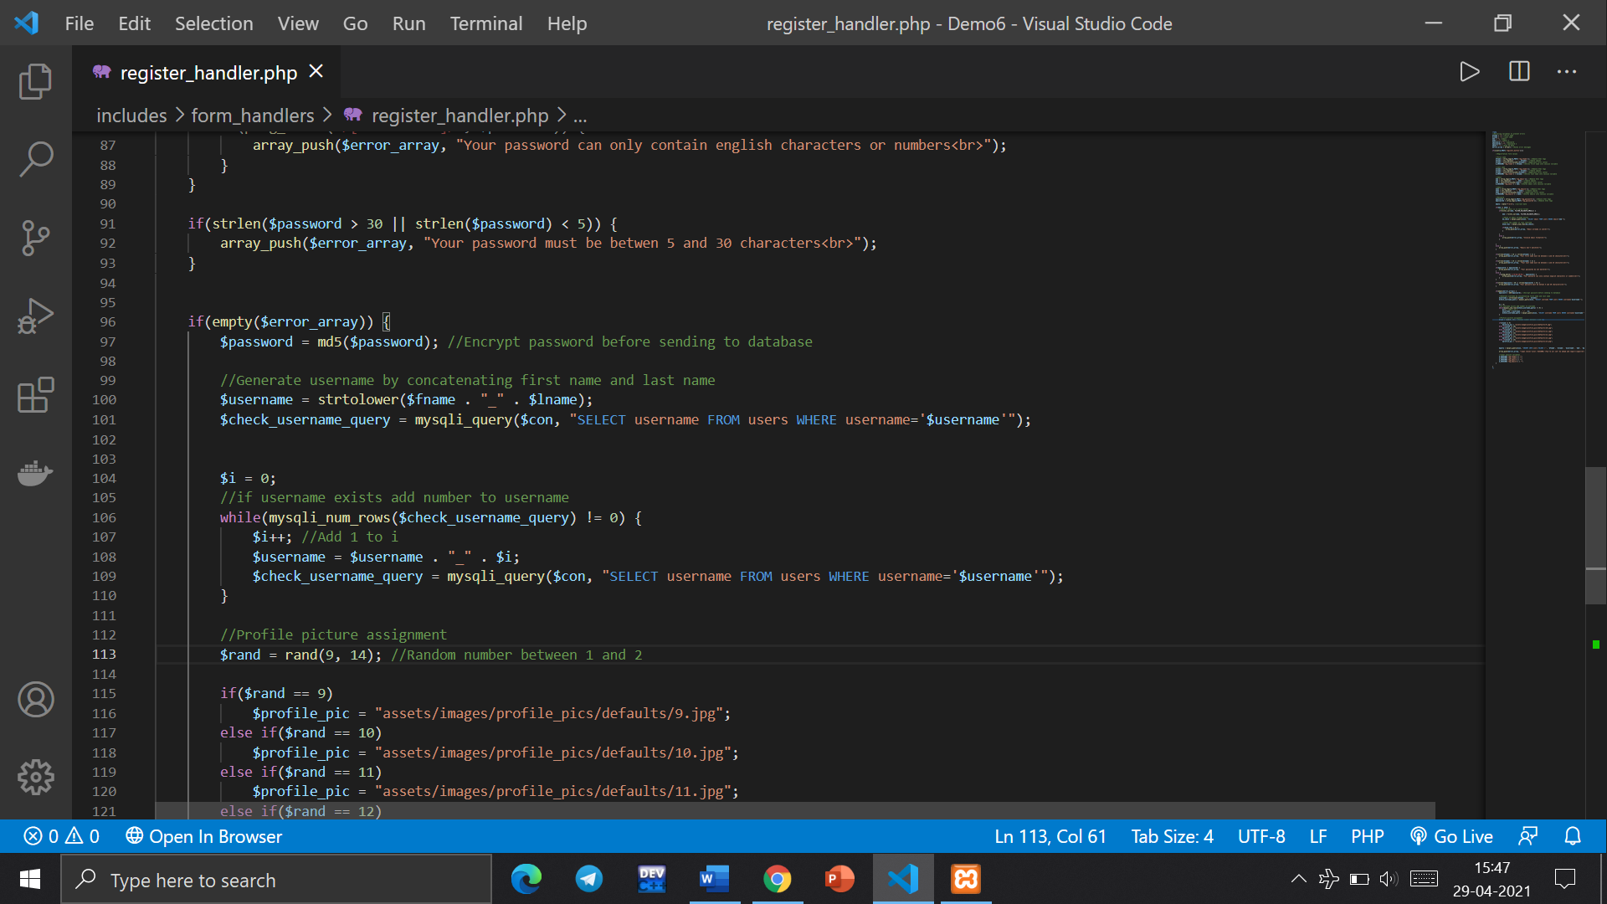

**Functions used:**

* **Md5:**

PHP is a server-side scripting language which implies that PHP is responsible for all the back-end functionalities required by the website. The authentication system is one of the most important parts of a website and it is one of the most commonplace where developers commit mistakes leaving out vulnerabilities for others to exploit. One example could be storing and using user passwords in its true form, which may lead to a situation where an unauthorized person gets the access to the database and the whole system is compromised. This situation can be easily prevented using password hashing. Password Hashing is a method which takes the user password( a variable-length sequence of characters) and encrypts it to a fixed-length password containing random characters from a larger set. PHP has a few functions that can be used to achieve the same like md5 function.

**Syntax:** string md5 ($string, $getRawOutput)

**Parameters:** The function an take up to a maximum of two parameters as follows:

$string: This parameter expects the string to be hashed.

$getRawOutput: This optional parameter expects a boolean value, on TRUE the function returns the hash in a raw binary format of length 16. **Return Type:** This function returns the hashed string (either in lowercase hex character sequence of length 32 or raw binary form of length 16).

* **Concatenation of first and last name**

**Concatenation Operator ("."):** This operator combines two string values and returns it as a new string.

* **Mysqli_query():**The mysqli_query() function accepts a string value representing a query as one of the parameters and, executes/performs the given query on the database.
* **Random profile picture assignment**

This code will be assigning each new user with a default profile picture. The project has a few funny pictures. The purpose of assigning a random funny picture to a new user is an attempt to reduce stress in this pandemic situation. As this platform is focussed on doctor and patients, the project attempts to avoid stress. This code is to randomly assign one of these funny picture as their profile picture so that all users don't look the same and also reduces stress as users will have to make one less decision in this pandemic situation which relieves some pressure off one’s head.

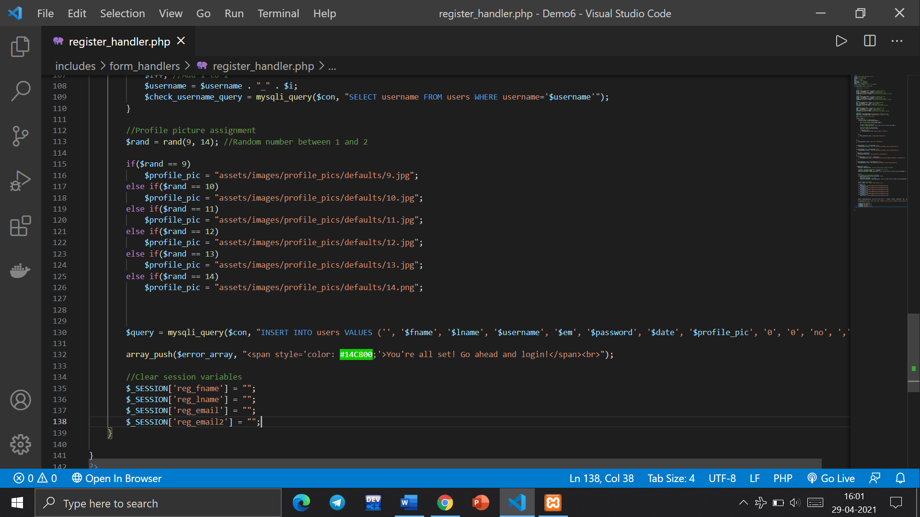

* **Inserting values into our database and clearing session variables.**

After all these steps, the values are inserted into users table in our database using INSERT command.

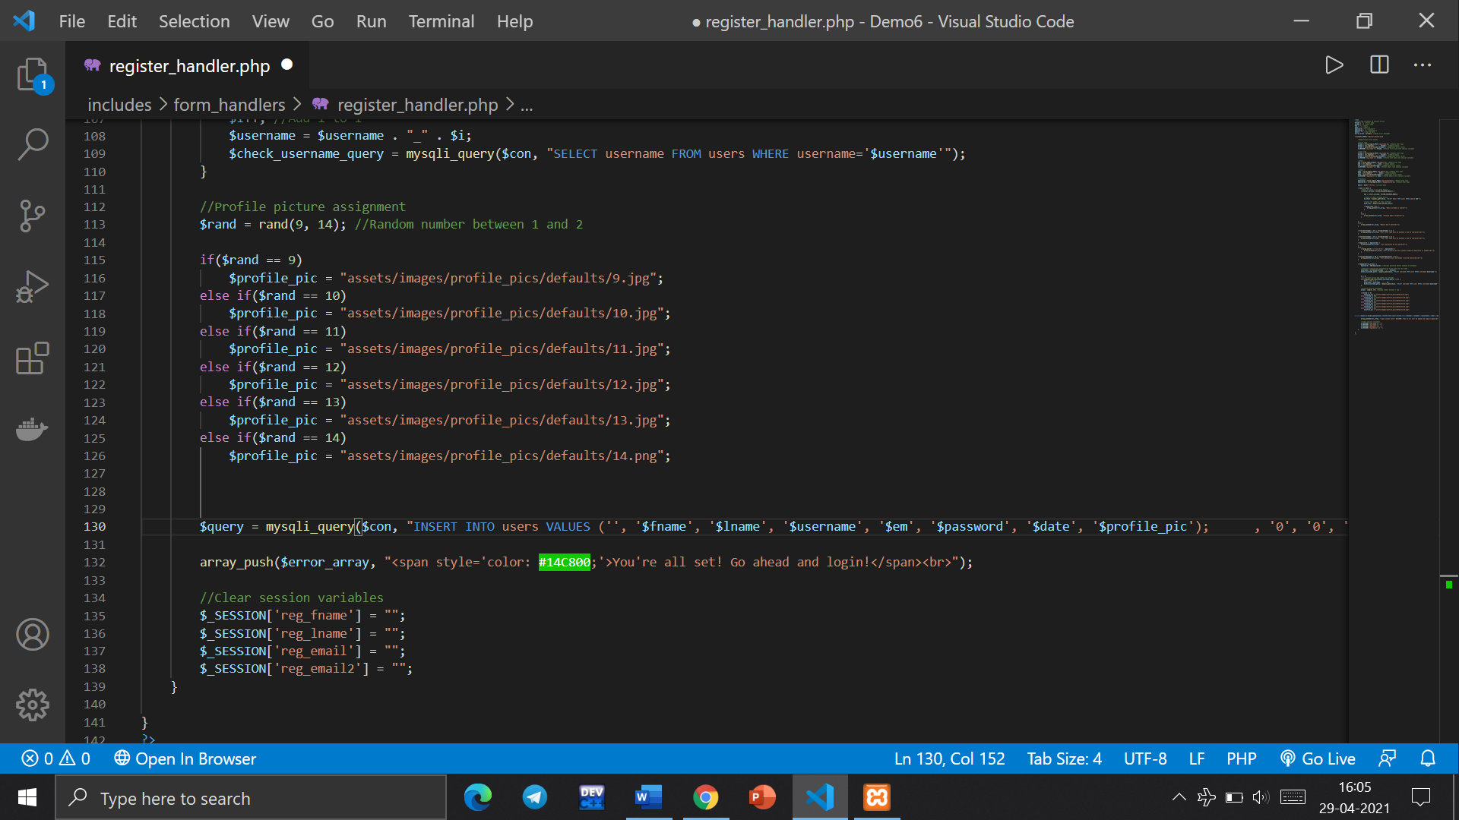

# Styling Registration Page using CSS

Cascading Style Sheets, fondly referred to as CSS, is a simple design language intended to simplify the process of making web pages presentable. Using CSS, you can control the colour of the text, the style of fonts, the spacing between paragraphs, how columns are sized and laid out, what background images or colours are used, layout designs, variations in display for different devices and screen sizes as well as a variety of other effects. The login page has 3 makor components to style: The background, the login form, login form header.

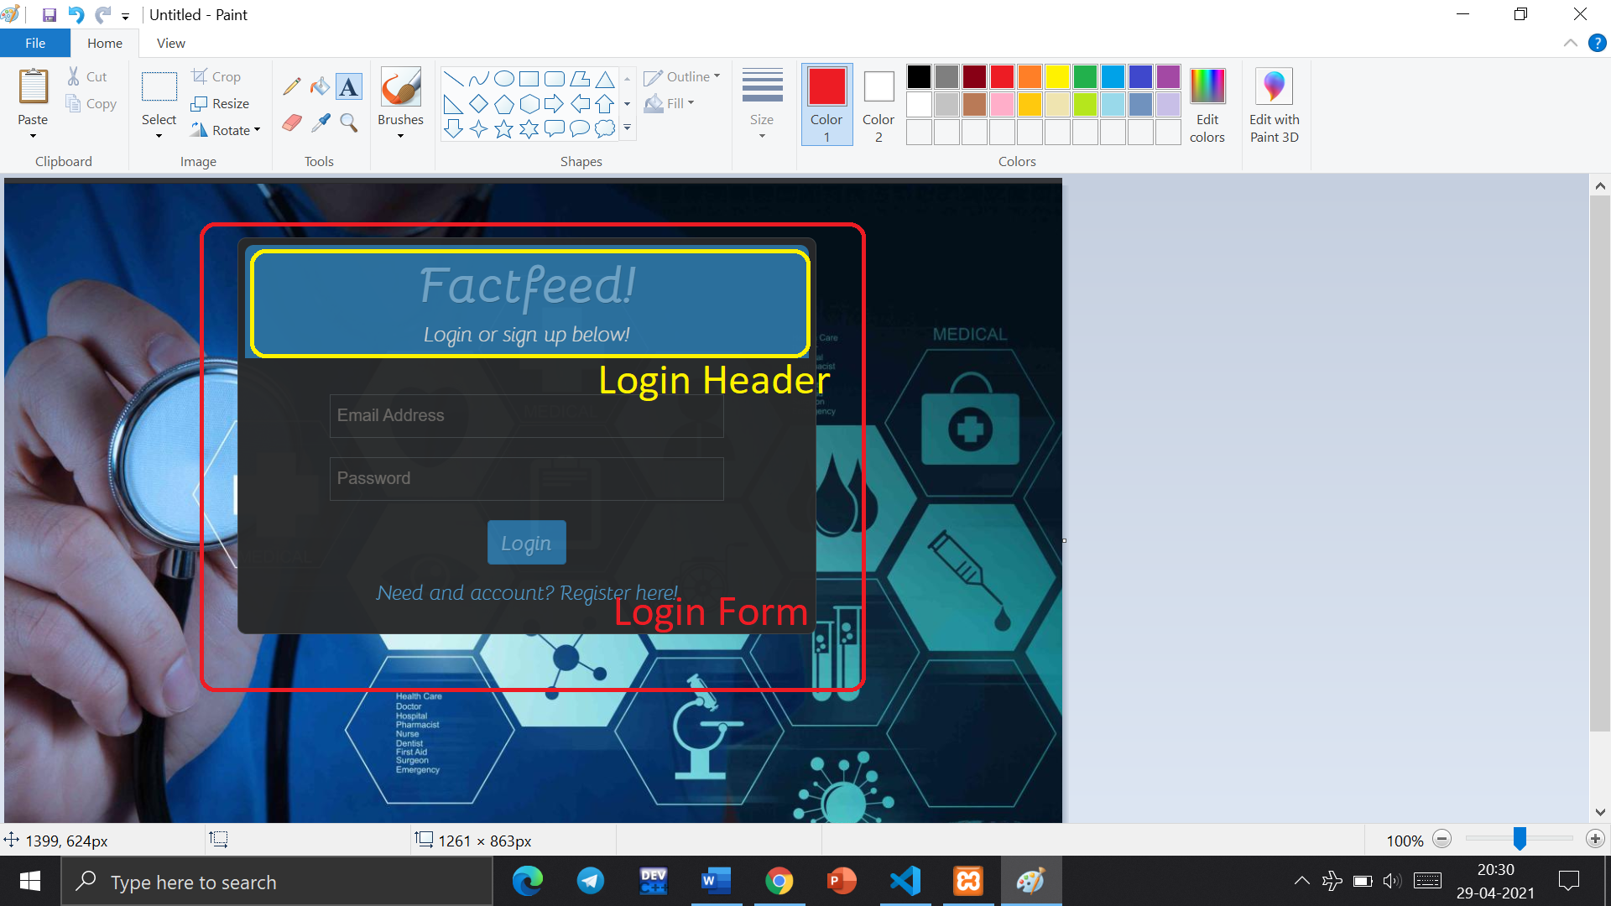

* **Using custom fonts**

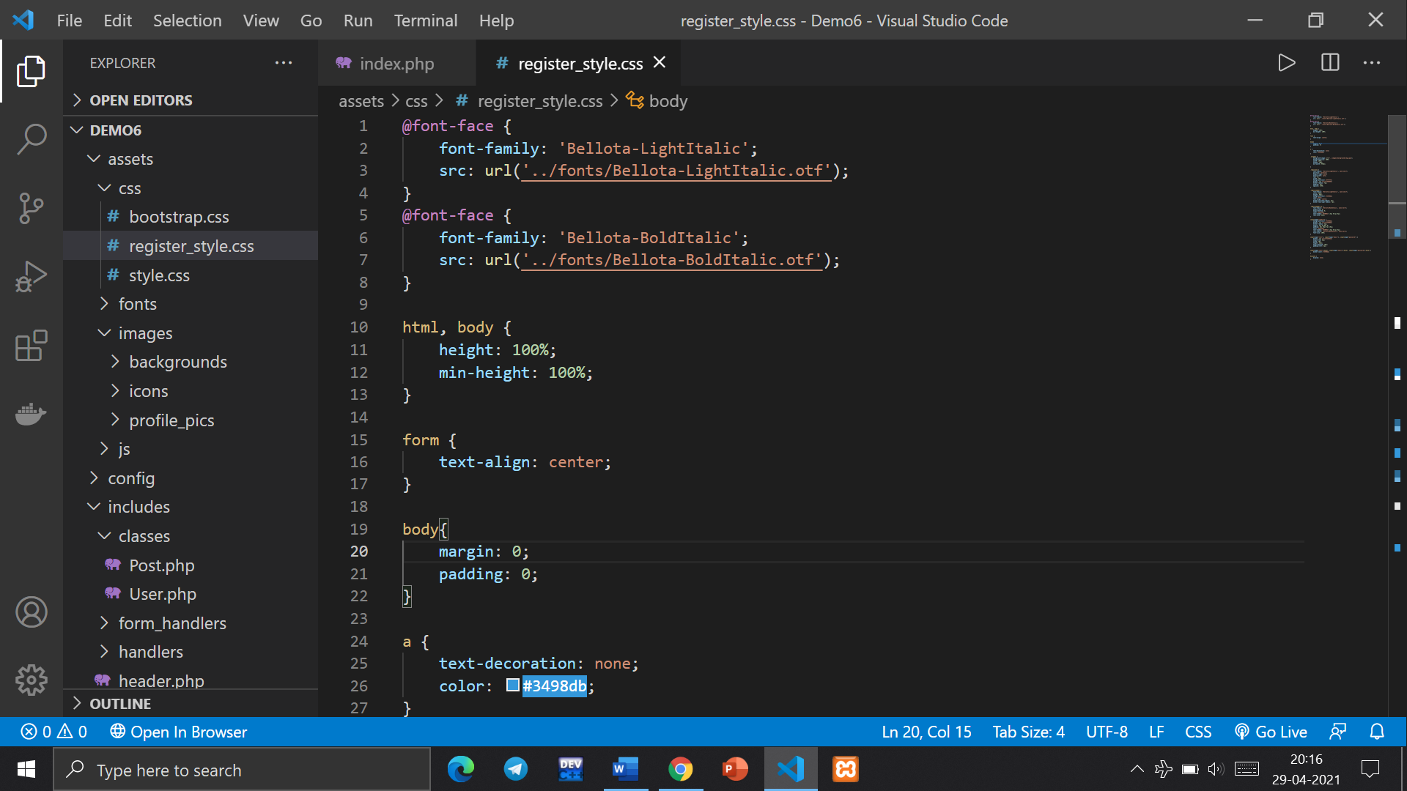

In the CSS @font-face rule is used to associate a font name that can be used in a style sheet. A font-family descriptor is used within the rule to name the font and an src descriptor is associated with an external font name. This can be used with downloadable fonts.

* **Adding background image**

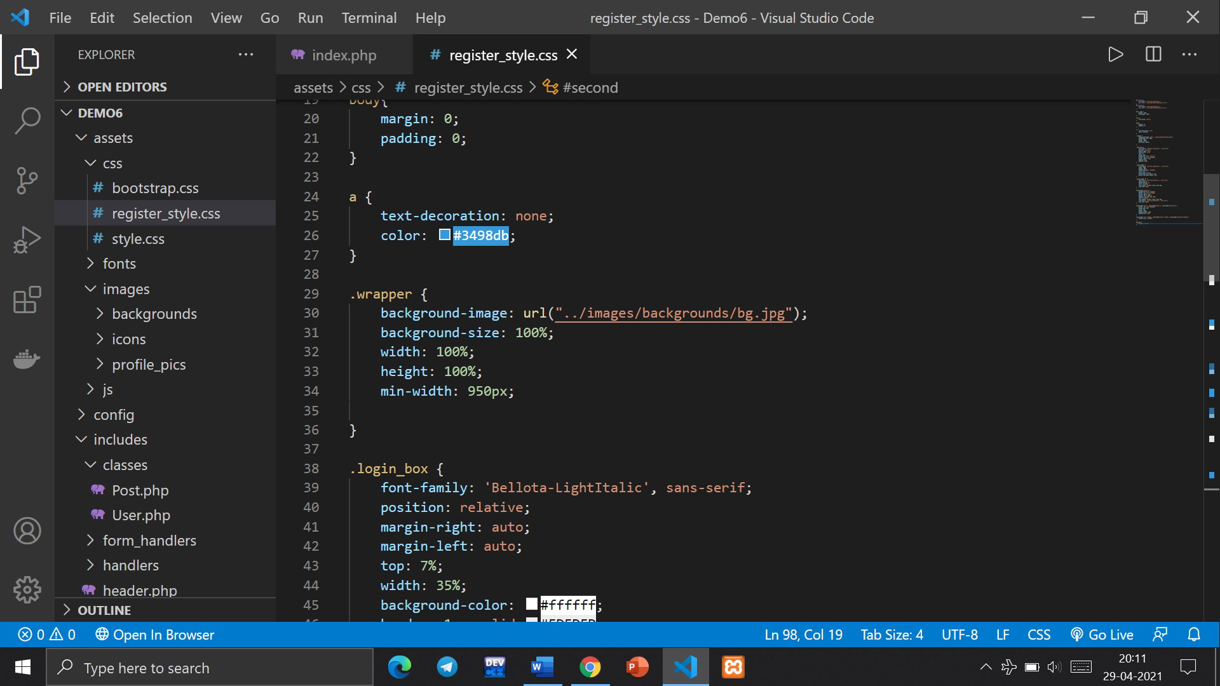

CSS background image property: The background-image property is used to set one or more background images to an element. By default, it places the image on the top left corner. To specify two or more images, separate the URLs with a comma.

**Syntax:** background-image: url('url')|none|initial|inherit;

**Property values:**

**url(‘url’):** When the background-image has an URL.

**none:** By using this property no background image will be displayed and this is by default

**initial:** It sets the property to its default value.

* **Styling login box**

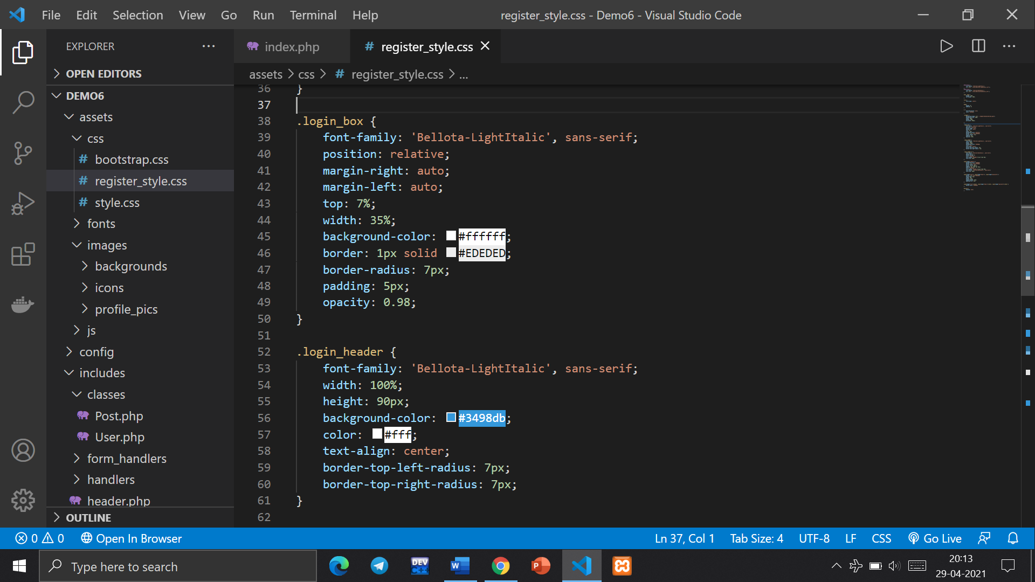

The panel is the white 'box' that the content sits in. You may not realise it, but you see these all the time on lots of websites.

* **Styling Login Header**

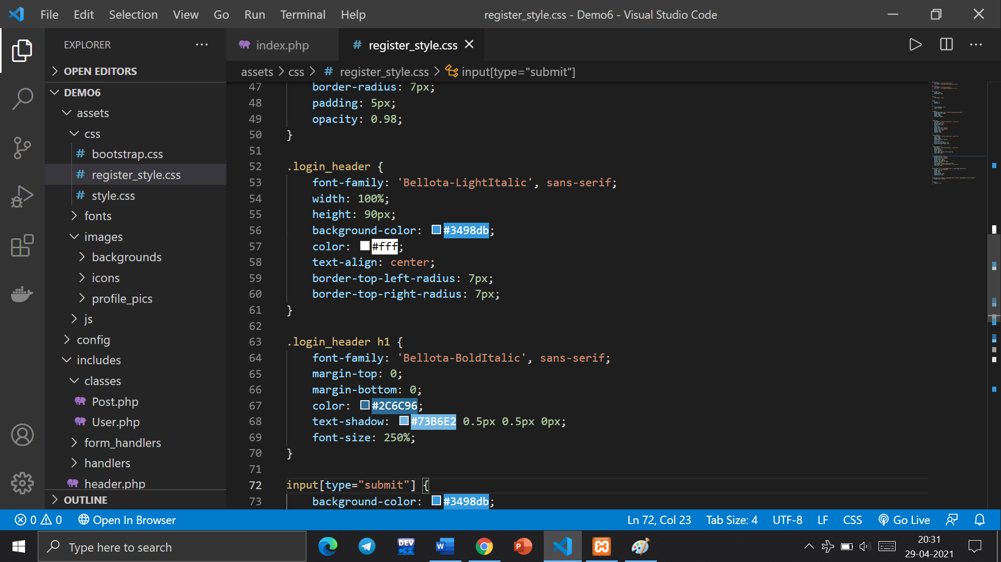

Styling the panel header to give the panel a blue header box which is where the title will go. Rest of the CSS code for styling the registration and login page is attached in the project. It includes styling of input boxes, showing/hiding login form (only showing one form at a time, either registration form or login form).

# Index Page

The main page has 4 major components.

* **The top bar:** It displays the site logo, home button, notifications button and the logout button.
* **The left panel:** It displays the user info of the user who is logged in. It shows the user name, user’s profile picture (which is randomly assigned), the number of posts and likes on the user’s posts.
* **The main column:** This is the main column on the index page. This is where users can upload their posts. The posts uploaded are sent to posts table in the database. The posts are uploaded using an html form. The complete index page is styled using CSS which includes setting the sizes of panels, colours of top bar, buttons, background colour etc.
* **Newsfeed:** The main column also has the newsfeed where users can view the posts uploaded by them as well as other friends. The posts have 2 options: like and comment. The count of likes and comments is also stored in their respective tables along with the respective post id. The comment box also uses a html form which is further styled using CSS.

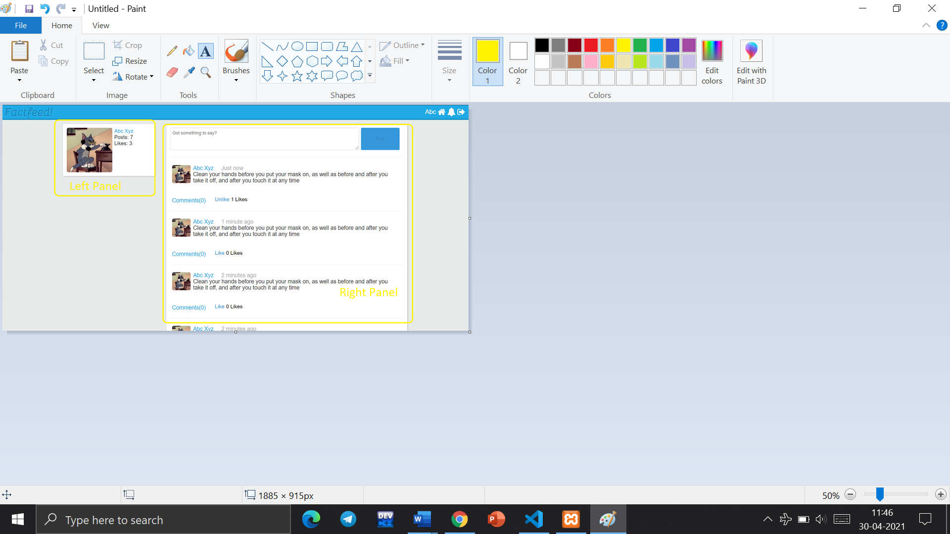

### Description of each component

* **The top bar:**

The top bar is contained in **header.php** file which is a header file that will contain all the code that we want to be present on every page. This includes the navigation bar, logo, icons etc. Here we add a link to Twitter Bootstrap. By simply adding the link to our header file, there is a whole bunch of styles that are already being applied to our content. Next, we are adding the blue bar that goes across the top of the page. It displays the site logo, home button, notifications button and the logout button. We are also going to add a simple 'logo' for our site much like the one we added when working on our register page. we use the icons from 'Font Awesome' to add links to different pages on our navigation bar. This header.php file is important as it uses a query to fetch all the details of user in an array which is used on every page. This header file is included in every other page. The top bar is further styled using CSS.

* **User details query**

This query fetches all the details of user who is logged in otherwise it directs us to the registration page. This query is most important as this information is required on every page. For example: without user details, we can not show the left panel, load user’s posts, comments etc. That is why it is included into the header file.

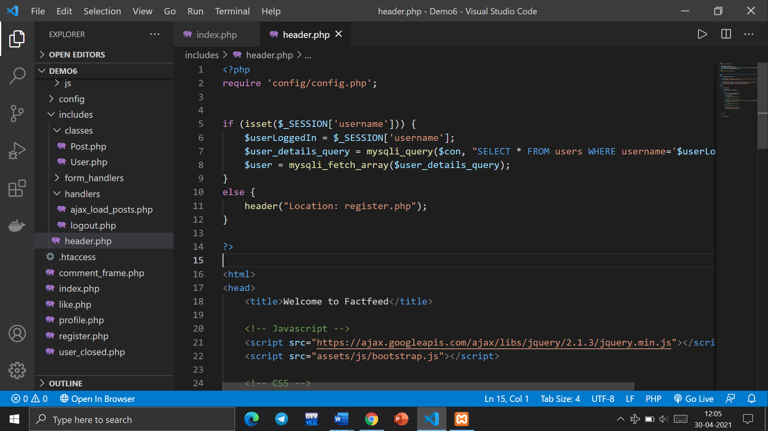

**Functions used:**

* The **mysqli_fetch_array() function** is used to fetch rows from the database and store them as an array. The array can be fetched as an associative array, as a numeric array or both.

Associative arrays are the arrays where the indexes are the names of the individual columns of the table. On the other hand, numeric arrays are arrays where indexes are numbers, with 0 representing the first column and n-1 representing the last column of an n-column table.

**Syntax:**

mysqli_fetch_array ("database_name", "mode")

**Parameters:** This function accepts two parameters as mentioned above and described below:

* **database_name:** It is the database on which operations are being performed. It is a mandatory parameter.
* **mode:** It can have three values – MYSQLI_ASSOC, MYSQLI_NUM, and MYSQLI_BOTH. MYSQLI_ASSOC makes the function behave like mysqli_fetch_assoc() function, fetching an associative array, MYSQLI_NUM makes the function behave like mysqli_fetch_row() function, fetching a numeric array while MYSQLI_BOTH stores the data fetched in an array that can be accessed using both column indexes as well as column names.
* **Mysqli_query():**The mysqli_query() function accepts a string value representing a query as one of the parameters and, executes/performs the given query on the database.

**Syntax** mysqli_query($con, query)

**Parameters**

**$con**(Mandatory) This is an object representing a connection to MySQL Server.

**query**(Mandatory) This is a string value representing the query to be executed.

**mode**(Optional) This is a integer value representing the result mode. You can pass MYSQLI_USE_RESULT or MYSQLI_STORE_RESULT as values to this parameter.

**Return Values** For SELECT, SHOW, DESCRIBE and EXPLAIN queries this function returns a mysqli_result object holding the result of the query in case of success and, false if failed. For other queries this function returns an boolean value which is, true if the operation/query is successful and, false if not.

* **The left panel**

This is the user’s details panel. It displays the user info of the user who is logged in. It shows the user name, user’s profile picture (which is randomly assigned), the number of posts and likes on the user’s posts. Using the query which was performed in header.php file, it fetches the profile pic, likes, posts, first and last name of the user from the array. This panel is further styled using CSS.

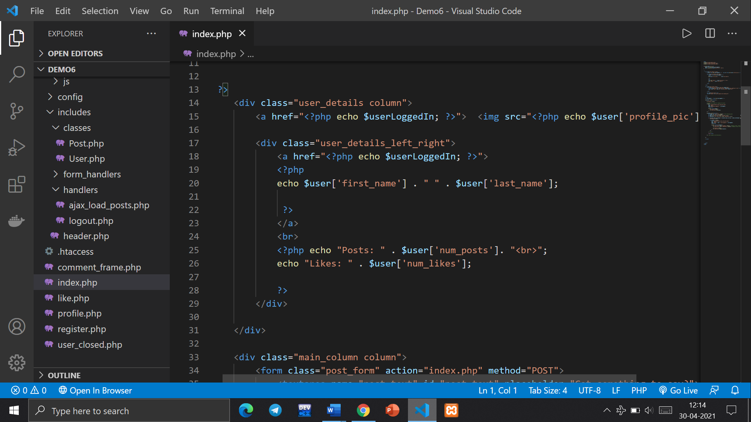

* **The main column or the newsfeed column**

This column has two major components. The post form which is used to upload posts and the post area where user’s view posts from other users. Newsfeed uses a object oriented approach.

In newsfeed, users can upload posts, view posts from their friends, like and comment posts etc. It also has the functionality of timestamps for every part (posts, likes and comments). Newsfeed is optimised in various ways. There is a User’s class which performs SQL queries and fetches required data for newsfeed. The newsfeed works on an Object-Oriented approach. It creates objects of user class and then displays output on the feed. The posts fetching part is also optimal. The newsfeed works by fetching only 10 posts from the database at a time. If the user scrolls down till the end only then another 10 posts are fetched from database.

* **Object oriented approach using a ‘Users’ class**

Object-oriented programming (OOP) is a programming paradigm based on the concept of "objects", which can contain data and code: data in the form of fields (often known as attributes or properties), and code, in the form of procedures (often known as methods). A feature of objects is that an object's own procedures can access and often modify the data fields of itself. OOP reduce program complexity. Also, reduce code rewriting. Make the source code more readable and manageable. It is a good abstraction concept.

Using users class, we can create objects of this class and use the functions of user class for every object. User class contains a bunch of useful functions for us to re-use throughout this website. The functions included in the users class are to

* get first and last name of the user who is logged in
* get number of posts of the user who is logged in
* get profile picture
* check if the account is closed or not
* get the friends list of the user
* get the friend requests sent by user
* friend requests received by the user
* function to remove friend
* function to send friend request

The functions of user class or the object created from the user class are used throughout the website.

* **Likes and comments**

Likes and comments of each posts are stored within likes and comments table respectively. Post id of each post is fetched using a SQL query from the posts table. Date and time of each comment is also stored in comments table to implement time stamp. Comments are taken through a html form and then inserted into comments table in database. the code for all functions is attached with the project.

* **Posts class**

Just like a class for users, the project uses a class for posts as well using which we can create objects of this class and use the functions of user class for every object. The main functions in this class are to submit posts, load posts from database and time stamp functionality for each post whether uploaded or fetched from database.

* Submit post function

This function has the following functionalities. Firstly, it strips the php and html tags if any from the post that is posted from user. This is done to prevent code injection vulnerability (details of which were discussed in the strip tags function used at time of registration). It also removes special characters or double spaces if any. Then the current date and time is fetched (we need this for timestamp). Then using functions from user class rest operations of fetching user name, count of posts posted previously etc are performed. Then using INSERT command, the post is added to posts table in database. And afterwards number of posts is updated for the user.

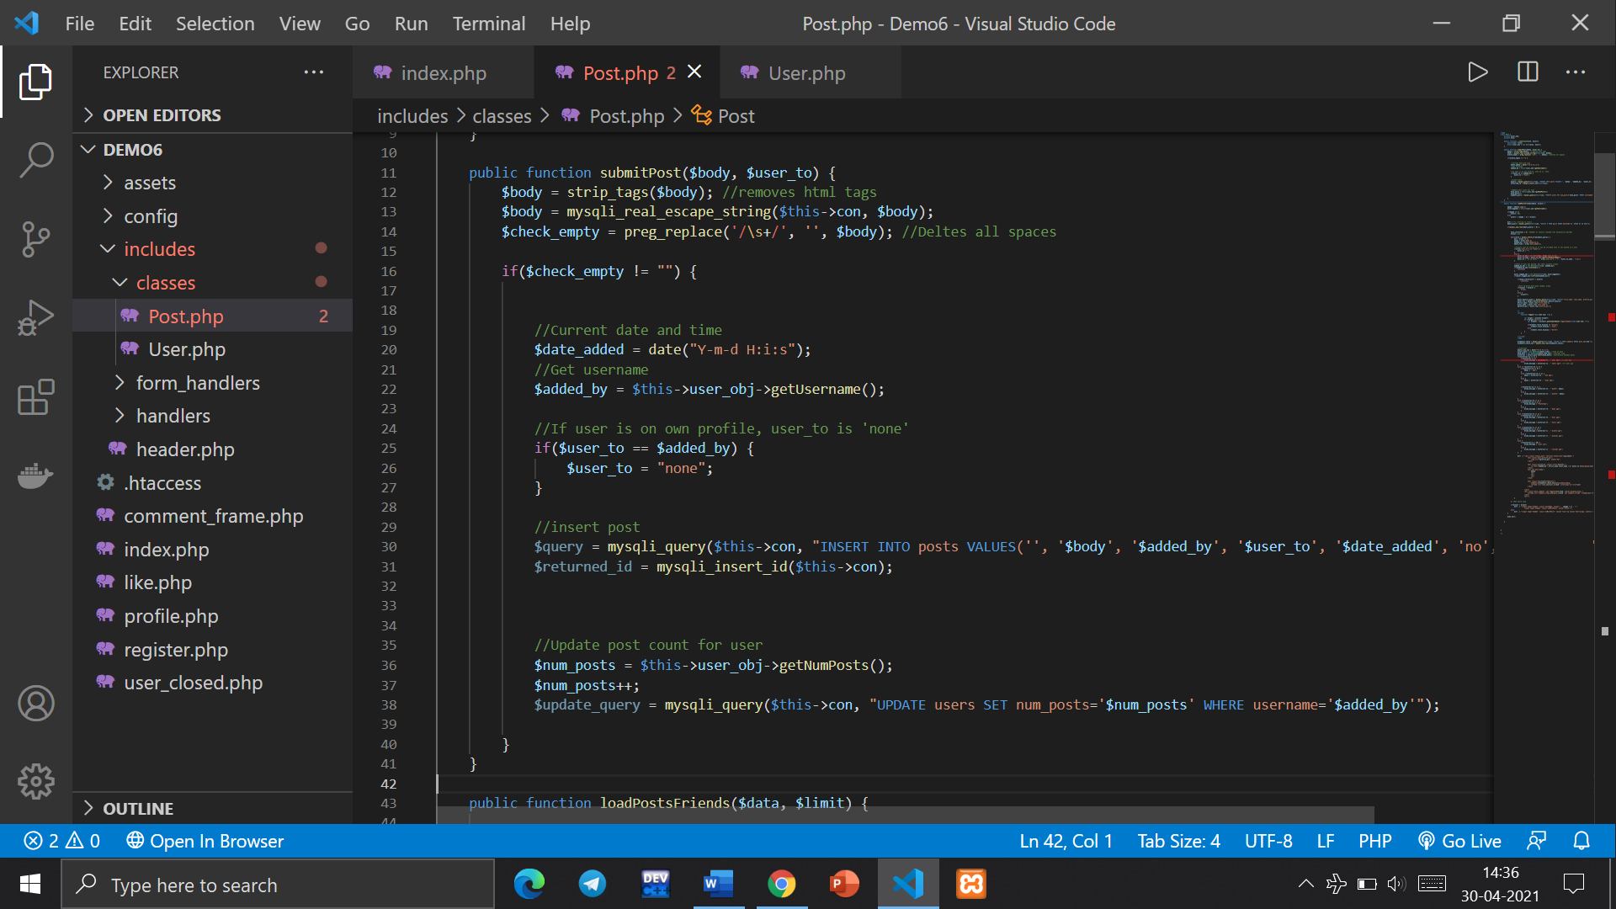

* Loading posts function

 This function retrieves posts from the database and output them to our newsfeed.

* It has a function that will return true or false depending on whether a user's account is closed or not. This function is used in numerous places all over our site.
* It also has a timeframe system that will tell us how long ago a post was posted e.g. "10 minutes ago" or "4 months 2 days ago".
* //Timeframe
* $date_time_now = date("Y-m-d H:i:s");
* $start_date = new DateTime($date_time); //Time of post
* $end_date = new DateTime($date_time_now); //Current time
* $interval = $start_date->diff($end_date); //Difference between dates
* if($interval->y >= 1) {
* if($interval == 1)
* $time_message = $interval->y . " year ago"; //1 year ago
* else
* $time_message = $interval->y . " years ago"; //1+ year ago
* }
* else if ($interval->m >= 1) {
* if($interval->d == 0) {
* $days = " ago";
* }
* else if($interval->d == 1) {
* $days = $interval->d . " day ago";
* }
* else {
* $days = $interval->d . " days ago";
* }
* if($interval->m == 1) {
* $time_message = $interval->m . " month". $days;
* }
* else {
* $time_message = $interval->m . " months". $days;
* }
* }
* else if($interval->d >= 1) {
* if($interval->d == 1) {
* $time_message = "Yesterday";
* }
* else {
* $time_message = $interval->d . " days ago";
* }
* }
* else if($interval->h >= 1) {
* if($interval->h == 1) {
* $time_message = $interval->h . " hour ago";
* }
* else {
* $time_message = $interval->h . " hours ago";
* }
* }
* else if($interval->i >= 1) {
* if($interval->i == 1) {
* $time_message = $interval->i . " minute ago";
* }
* else {
* $time_message = $interval->i . " minutes ago";
* }
* }
* else {
* if($interval->s < 30) {
* $time_message = "Just now";
* }
* else {
* $time_message = $interval->s . " seconds ago";
* }
* }
* **AJAX**

When the page is loaded, all posts are being pulled from the database and shown to the user. If we have a large number of posts, this is not a very efficient way of doing things. This load posts function ensures that when the user scrolls to the bottom of the page, only then it loads more posts. The function also uses AJAX to avoid unnecessary reloading of the page. Ajax is an acronym for Asynchronous JavaScript and XML. It is used to communicate with the server without refreshing the web page and thus increasing the user experience and better performance.  AJAX is a technique not a programming language which is used by the developers to make the websites behaving like desktop applications. It operates on the client-side for creating asynchronous web applications. AJAX is a group of technologies that uses number of web technologies for creating a set of web development techniques.

AJAX allows multiple web pages to be updated one by one by exchanging the data with the web server in the background. Which means that the part of the web pages can be updated without refreshing the whole page again and again.

**Characteristics of Ajax:**

* **In AJAX web page acts as application:**AJAX is much more important than smarter than HTML since they act as desktop application. AJAX interact with back end server without any hassles and they are more responsive than HTML.
* **Data is stored on server unlike pages:**In HTML when the user sends a dynamic data to the server, the server converts the whole HTML page into the format which is readable by client. In AJAX there is no need of doing the above process because the AJAX server does not have to convert all the pages, it directly receives and sends the data to the client-side. In AJAX server deals with data and not in pages.
* **Provides continuous and dynamic user experience:**User can interact with page and data can be stored at the same time without refreshing the page. In other cases, we have to wait for the response to be processed and to get results but in the case of AJAX, we get a synchronous response. We can perform multiple task with AJAX since it provides nonlinear workflows.

# INNOVTIVE APPROACH, CONCLUSION & ANALYSIS

* Creating a social networking platform comes with great challenges like identifying target audience, defining features and functions, choosing the right technology, structuring the code, dealing with security threats, keeping users’ data safe etc. By making this project I faced such challenges and solved them.
* I learnt and used many new technologies in past few weeks like XAMPP, Php programming, AJAX, SQL etc and also used innovative approaches to solve various challenges associated with a social networking platform.
* Throughout this project, I have used Object-Oriented Approach and designed many functions which reduces the complexity of code and improves overall efficiency.
* For reusability of code, I have made classes for the data and instructions which are required at multiple places. I have used combination of Php, JavaScript, jQuery and AJAX to reduce the complexity of the code. The entire code base of the project requires less than 4MB.
* I have implemented encryption for data security. Vulnerable data like passwords are inserted into database only after encryption. Even if someone is having the data in database still the encrypted data will remain protected.
* Before inserting data into database, it is stripped from any html or php tags to prevent code injection. This makes the database safe from potential code injection attacks.
* To improve user experience session variables have been used so that user won’t have to type details again if some error caused page reload. Also, because of the random profile picture assignment function users have to make one less decision in this pandemic situation which relieves some stress.
* To improve how the data is fetched from database, I have implemented a function using which data is fetched in bundles and is loaded on the web page without reloading the complete webpage.

# REFERENCES

* Caers, R., De Feyter, T., De Couck, M., Stough, T., Vigna, C., Du Bois, C. (2013). Facebook: A literature review. New Media & Society, 15, 982–1002. doi:10.1177/1461444813488061
* DiStaso, M. W., Bortree, D. S. (2012). Multi-method analysis of transparency in social media practices: Survey, interviews and content analysis. Public Relations Review, 38, 511–514. doi:10.1016/j.pubrev.2012.01.003
* Gholami-Kordkheili, F., Wild, V., Strech, D. (2013). The impact of social media on medical professionalism: A systematic qualitative review of challenges and opportunities. Journal of Medical Internet Research, 15, e184. doi:10.2196/jmir.2708
* Issa, Tomayess & Kommers, Piet. (2013). Social networking for web-based communities. International Journal of Web Based Communities. 9. 5-24. 10.1504/IJWBC.2013.051292
* Vasilescu B, Filkov V, Serebrenik A (2013) Stackoverflow and github: Associations between software development and crowdsourced knowledge. In: Social Computing (SocialCom), 2013 International Conference On, 188–195.
* Kapoor, K.K., Tamilmani, K., Rana, N.P. et al. Advances in Social Media Research: Past, Present and Future. Inf Syst Front 20, 531–558 (2018).
* Cao, X., Guo, X., Liu, H., & Gu, J. (2015). The role of social media in supporting knowledge integration: A social capital analysis. Information Systems Frontiers, 17(2), 351–362.
* Chen, A., Lu, Y., Chau, P. Y., & Gupta, S. (2014). Classifying, measuring, and predicting users’ overall active behavior on social networking sites. Journal of Management Information Systems, 31(3), 213–253.
* E. Aguirre, A. Roggeveen, D. Grewal, M. Wetzels The personalization-privacy paradox: Implications for new media The Journal of Consumer Marketing, 33 (2) (2016), pp. 98-110
* Barnes, N. G., & Lescault, A. M. (2011). Social media adoption soars as higher-ed experiments and reevaluates its use of new communications tools. North Dartmouth: Center for Marketing Research. University of Massachusetts Dartmouth.
* Arnold, N., Paulus, T. (2010). Using a social networking site for experiential learning: Appropriating, lurking, modeling and community building. The Internet and Higher Education, 13, 188–196. doi:10.1016/j.iheduc.2010.04.002
* Briones, R. L., Kuch, B., Liu, B. F., Jin, Y. (2011). Keeping up with the digital age: How the American Red Cross uses social media to build relationships. Public Relations Review, 37, 37–43. doi:10.1016/j.pubrev.2010.12.006

# Plagiarism Report

Drive link

<https://drive.google.com/file/d/1ODyo4z4b2mHDoUwu6KnGC16mJdHrGsVf/view?usp=sharing>

